
ELEE 4220: Feedback Control Systems
Magnetic Levitator
Emerson Hall, Nevan Mukherjee, Jordan Williams
02/28/2025

Project Overview

A description of the project
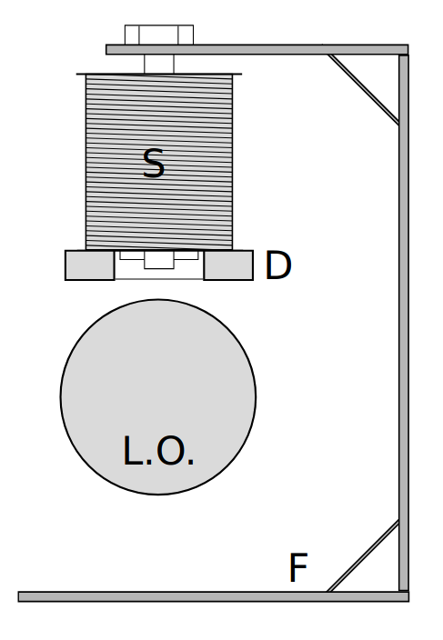  Figure 1 | In this project, we will control a DC current that generates a magnetic field. This B field will generate a magnetic force, which will act on a ferromagnetic object. This object will appear to be “levitating” when the control system effectively implements a magnetic force that is equal to the gravitational force pulling the object down, thus being in physical equilibrium. A schematic taken from Dr. Haidekker’s instructions for the project are shown in Figure 1.

Team Charter

Team Members and Responsibilities
Nevan’s Philosophy | I like to work independently as much as I can and come together as a team to patch up any holes in our understanding together. I think my strengths lie in working with hardware, like resistor bridges, OPAMPs, transistors, etc. Furthermore, I took Electromagnetics last semester, and we talked about the vector math related to B-fields, their imposed magnetic forces, and how that force impacts an object. With this understanding, I believe I can help troubleshoot the logistical issues of working with the force and field vectors in our system.
Jordan’s Philosophy | My strength is predominantly working with hardware but I will work with whatever the team needs for project success.
Emerson’s Philosophy | I prefer to work independently while collaborating with the team to integrate and refine our individual contributions. My expertise lies in software development, particularly coding.

Timeline
We plan to meet on Wednesdays at 2:40 PM to collaborate, exchange ideas, and ensure alignment on project progress. Additional meetings will be scheduled as needed based on project requirements.

Milestone Number | Due Date | Description | Brief Plan
1 | 2/28/25 | Initialization Docs/Planning | Complete by the time this document is submitted.
2 | 3/28/25 | Test hardware and get a mathematical model for your plant | In this milestone, we test all our hardware. The first step is to get the hardware, and we need to decide on what Hall Effect we want to get, and then wait for it to ship to us.  Once we get the hardware moving and shaking that first week, we can try to hook the sensor up to the Pico and get readings  We plan to research a good Hall Effect over the spring break. During the week after the break, we will inform Dr. Trudgen which sensor we want and wait for it to ship to us. While we wait we can do some preliminary testing and play around with the current from the power supply as well as the materials we have in our possession. We can also try to do some first principles modeling to predict the behavior of the sensor.  Once we get the hall effect, the next week (17th) we’ll do a bump test on the sensor with a max PWM input and see if we can fit a first or second order mathematical model to the data.
3 | 4/11/25 | Start designing your controller | We plan on using the Control System Designer in MATLAB and our knowledge of root locus to start designing the controller. We’ll figure out the details at a later time.
4 | 4/23/25 | Final tuning/submission | By this date we need to be completely done. This means using MATLAB’s Control System Designer, PID tuner, among other tools and testing methods to get the theoretical controller model working as effectively as we can get it to work. Details TBD later.

Broken Hardware
Each team member is responsible for the proper handling and maintenance of assigned hardware components. If any hardware becomes damaged, we plan to replace it as necessary. Smaller components, such as resistors, will be sourced from the University of Georgia’s supplies.

Conflicts
The team will dispute conflicts through internal discussions. If the resolution cannot be reached, Dr. Trudgen will be consulted for advice.

Policies:
- Per UGA Engineering policy (set by Dr. Hilten lab manager – not me) this lab is to not have food or drink. At any point you need food or drink, go have it outside the lab. Failure to do this will first result in a grade letter deduction on the project. Then two grade letter deductions in the lab, then a course grade letter deduction in the class. Remember this policy is 24/7.
- Your team are the only ones to touch your hardware. The class can have general collaboration (see syllabus policy), but physically touching any aspect of the hardware is reserved to only the team. Same grade deduction policy applies.
- That the team will do original work. See the syllabus policy for AI. Generally speaking, AI shouldn’t be used for this course.

I agree - Nevan Mukherjee
I agree - Emerson Hall
I agree - Jordan Williams

List of Parts

Item | Status | Est. Cost | General Description
3D printed Platform | In Possession | Free | White 3D print that acts as the physical space where the setup can be implemented.
Transformer wire | In Possession | Free | Used to create a solenoid that will produce a vertical magnetic field that will be controlled to counteract the force of gravity acting on the levitated object, resulting in the object being in equilibrium.
Power supply | In Possession | Free | 30V 5A power supply will allow us to supply enough current to induce a strong enough B-field (and by extension strong enough magnetic force
Hall effect sensor | Researching | ~$10-20 | Used to detect the magnetic field around the levitated object and provides feedback to the control system.
Magnet | In Possession | Free | It is levitated by the magnetic field generated by the electromagnet.
Ferromagnetic material |  |  | A material made of iron could work, something we know the relative permeability of fairly well.
Mosfet | Provided | Free | Used to control the current flowing through the solenoid, which in turn controls the magnetic field that levitates the magnet.
Spool for bobbin |  |  | Spool to wind the transformer wire onto
Microcontroller-  (Arduino or Pico) | Provided | Free | A small computer that processes input from the distance sensor and adjusts the solenoid driver to maintain a constant levitation height of the magnet
Capacitors/Resistors | Provided | Free | Passive electronic components used to stabilize and filter signals in the driver circuit, ensuring smooth operation of the electromagnet and control system.
Hall Effect Sensor research:

We will be depending on a Hall effect sensor to get a continuous reading of the output position of the magnet to compare to our reference. Here is our criteria for finding a good Hall Effect sensor that will be effective for our specific application:

- Resolution: The control loop needs to know when the magnet moves, even by a small amount (say a couple mm) in order to get an accurate position signal and by extension error signal. Furthermore, we are linearizing the system right around the desired equilibrium position (gravitational force is nonlinear in terms of distance due to $d^{2}$in denominator). This further brings to light our need for high resolution - i.e. the sensor being able to detect very small changes in magnetic field (and by extension position of levitated object) to keep within the small range of our linear model.
- Accuracy: B field is a function of distance. We can use software transfer functions to get the distance, but we need to ensure the actual B-field reading from the Hall Effect sensor is as close to the true B-field as possible.
- Cost: At the end of the day, we can’t expect to get the most expensive Hall Effect sensor we can find in order to get the best resolution and accuracy. Considering how cheap these sensors tend to be, I expect to limit the cost of this purchase to $10-20

